BOLOGNA – PRAGUE – BERLIN
Education Policy Paper
Proposal for the Agora in Athina, November 2002

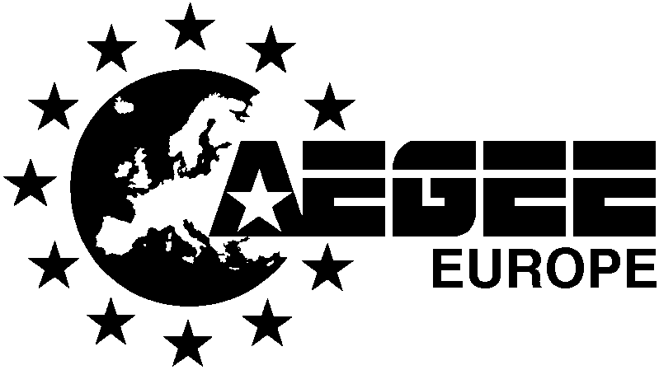

Motivation
In the last years Europe has faced major developments in the field of Education. Following:
- the UNESCO World Declaration on higher education for the twenty-first century: vision and action (1998);
- the Sorbonne Joint Declaration (1998)
- the Bologna Declaration on the European Higher Education Area of the European States (1999);
- Article 14 of the Charter of Fundamental Rights of the European Union (2000);
- Undertaking “Educational Services” as a field of negotiating commitments of the GATS negotiations in the Doha round (2001)
We see the need of stronger involvement and participation of European students – who are directly involved by the decisions and commitments taken.
In this Policy Paper one will find visions and ideas regarding various aspects of Education Policies which are close to the interests to European Students. In 2002 AEGEE has carried out several workshops and meetings concerning the development of educational policies in the framework of the “Bologna – Prague – Berlin” Project. This project aims at gathering the ideas of European students and bringing them to decision makers.
The Paper is a follow-up to the opinions reflected in the AEGEE Language Policy Paper (2001) and the Statement on the Future of European Education (2002) – ratified by the AEGEE-Europe General Assembly.

Main Principles
This paper represents the vision of AEGEE members on the developments of specific fields in higher education. In particular we put more effort on:
- student participation in educational policies;
- promotion of the European Dimension, especially through tuition of foreign languages;
- better access and facilitation of student mobility;
- cautious implementation of the 3-tier system;
- flexible and student centered implementation of the developments in Higher Education (Life Long Learning, Non formal education, ICT);
- extreme cautiousness in the link between Higher Education and GATS commitments.

European Dimension
The underdeveloped “European feeling” of Europeans stems from inadequate tuition at all levels of education – also Higher Education.
To counteract to this deficit we propose these practical measures:
- Stronger tuition of foreign languages (see next point);
- More attention to raising awareness of history, culture and literature of other European countries;
- More classes about the basics of European integration and the ideology behind it.

Languages in Europe
We believe that the tuition of foreign languages is a vital part of fostering the European identity as well as a channel of promotion cultural diversity in Europe.
Every student, at the end of his/her studies, should have communicative skills in English and another European Language other than his/her mother tongue. English will be considered as a language for communication among students of all countries, whereas the second European Language will be a vehicle to increase cross-border cultural exchange. To achieve this:
- Courses of foreign languages to be mandatory no matter what studies;
- Academic credits to be recognised in languages (where not already existing);
- Parts of the studies to be taught in a different language, preferably in another country than the homeland;
- Less widely spoken languages to be made more accessible and promoted.

Student Mobility
We see the Student Mobility as a vital action bringing the Europeans together, and enhancing the cultural exchange. Being a Youth NGO with a particular focus on Higher Education in Europe, AEGEE wants to emphasise some very relevant aspects for the full implementation of mobility in education:
- Removal of all structural/social obstacles to horizontal and vertical mobility for students, teachers, and administrative staff across all Europe, promotion of student mobility, access to study/training opportunities abroad and related services, all over Europe;
- Supporting and contributing to information dissemination and promotion of EU actions, especially towards student mobility in Higher Education (SOCRATES/Erasmus and Erasmus World). We see an outstanding need of stronger involvement of students into planning of Community Actions in the field of Higher Education;
- Encouraging and ameliorating mobility by preparing students better, increasing their awareness and responsibility, therefore ensuring quality of mobility program;
- Supporting and promoting the execution of ICT-based initiatives, in particular those ones which utilize distance-learning and e-learning for expanding virtual/physical mobility. It must be made clear that these actions should in no way substitute real mobility;
- Expanding financial schemes for student mobility on national as well as community level as well as making better use of already existing schemes Implementing joint-actions, meetings and discussion fora on the issues of youth mobility in a European education area, together with other student organizations in Europe;
- Further implementation of mobility programmes in all European countries, prioritising those countries currently excluded or newcomers of the SOCRATES/Erasmus programme, such as former-Yugoslav countries, some Eastern European countries, etc.

Recognition of Studies
We believe that the extension and perfection of the credit point system and the transfer systems is a significant and important development for mobility to aid European integration. The ECTS proved to be a well-functioning standard for European accreditation.
- ECTS is an important tool to help to create the common European educational area without compromising national educational systems and should be implemented where yet not present;
- ECTS must develop towards an accumulation system to fulfil its role of facilitating lifelong learning in Europe. In order to provide a better transparency (of the student performance) the Diploma Supplement is welcome.
- Due to forces like globalisation and advances in information technology learning has to become more student-centred and flexible as credit-based systems are developed.

3-Tier System
The convergence towards the 3-tier system is a vital step towards the creation of the European Higher Education Area. Nevertheless the potential negative consequences of the convergence need to be recognized.
- the introduction of Bachelor degree strongly modifies the study cycle leaving much less flexible time for non-curricular activities, as well as all forms of non formal education, thus leading to a much more theory oriented study period
- the 3-tier system makes the current student mobility schemes impractical, as there is much less time for academic exchange in the study cycle, an solution could be the promotion of Masters-based mobility programmes

Lifelong and Lifewide Learning
To learn is not simply to go to school anymore. For the 21st century average person, to learn should encompass the whole spectrum of formal, non-formal and informal forms since pre-school to post-retirement. The magnitude of such changes calls for a complete new approach towards the whole educational system.
In order to achieve aim the Lisbon European Council in March 2000 of Europe becoming the most competitive and dynamic knowledge-based society in the world this reason the two processes should enhance and complete each other. This should not necessary imply a new process, rather it should imply a more coherent and use of existing instruments and resources.
In order to harmonize these two processes in a coherent mode, we believe and will strive for the following areas that are considered to be of major importance:
- to create and promote a system of certification and accreditation not only for recognition of formal studies, but also a system that should allow the premises of recognition among formal and non-formal forms of education as well
- to recognize new forms of non-formal education, including various forms of volunteer activities
- to improve the responsiveness and flexibility of the education providers in order to meet better the learners needs
- to foster the six key messages of the Lifelong Learning Memorandum, especially “Raising levels of investment in human resources”, “Innovation in teaching and learning” and “Valuing learning”
- to make use of the distance education potential within the context of new technologies and need for enhanced flexibility
- all fields of studies at all level should take better stalk of the New Technologies as well as raise the computer and internet literacy of everyone attending courses

Globalisation and Educational Matters
The globalisation process is involving more and more fields of economic and social life. In the ongoing Doha Round of the World Trade Organisation negotiations – commitments and negotiations are being undertaken by several countries (including also European ones) concerning Higher Education. Currently only Trade ministries are involved in the decision making, the negotiations are carried out behind closed doors and several stakeholders of Higher Education have very limited impact on the process
Submitting Higher Education into the framework of GATS regulations might lead to extreme consequences. Clear regulations need to be undertaken which should counteract:
- the massification of taught courses and pure market orientation of Higher Education
- social exclusion and the abolishment of equal opportunities for individuals willing to undertake higher studies
- carrying out of market-oriented research only.
What we demand is:
- involving not only trade/economic ministries but especially academia, including the student community, in the decisions being taken
- strong cooperation in this field, in order to preserve not only the interests of for-profit driven institutions but all concerned stakeholders (public universities, ministries of culture and education, student communities).

Student Participation
We see a strong need for enhancing the student participation in the Bologna Process as well as other discussions concerning HE policies. Involvement of students should not be in any way exclusive and a broad spectrum of student visions should be represented. AEGEE also believes in the need of strong students presence at the

Summary
Concluding, AEGEE-Europe has carried out a research of expectations and needs of European students concerning the development of Higher Education policies.
The message we want to convey is very clear:
- stronger involvement of students voice in decisions esp. those concerning GATS negotiations and the Bologna Process is needed
- measures aimed at promoting access to Higher Education, strengthening the European values in Higher Education, mobility, Lifelong and Lifewide Learning need to be undertaken.

More Information
To learn more visit the AEGEE Bologna Portal: www.aegee.org/bologna.
To learn more about AEGEE visit www.aegee.org.
For comments or feedback write to the Bologna-Prague-Berlin Team at B-P-B@aegee.org.

