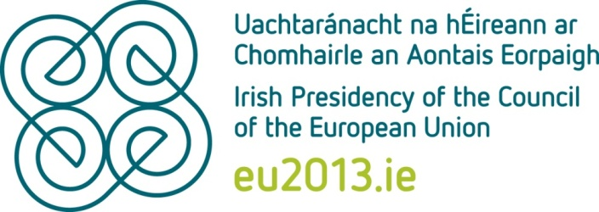

For Stability, Jobs and Growth
The year 2013 will usher in a new phase in the European Union’s drive for recovery. The Irish Presidency of the Council is about securing stability and ensuring that it leads to jobs and growth. Working together with our fellow Member States, the EU institutions and other stakeholders, the Irish Presidency will be that of a recovery country driving recovery in Europe.
Ireland celebrates 40 years of EU membership in 2013, which is also the European Year of Citizens.
We believe the EU must work more to respond to the common problems that we face. Member States must ensure that the Union’s architecture matches the realities of increasingly interconnected economies within and outside our borders. Overall, we in the Union must implement what we have agreed, strengthen our governance, invest in growth and job-creation, develop a Single Market for the future and renew our engagement with our external partners.
No time can be lost. The EU’s principal project for 2013 and beyond is to restore prosperity in a fair and sustainable way over the longer term.

Core priorities for the Irish Presidency
In choosing our priorities from the current agenda of EU legislation and initiatives, the same question was always asked – “does this make a difference?”. The key areas where the Irish Presidency aims to achieve this are:

People-centred recovery, designed to last
We need to first ensure lasting stability, starting with the necessary renewal of economic governance in Europe. Key areas for progress will be Banking Union and strengthening financial regulation, coupled with improved economic coordination through the European Semester process.
In tandem with this, the Irish Presidency will place a spotlight on youth unemployment throughout our six months in office. We intend to ensure momentum behind the Youth Employment and Social Investment Packages and secure agreement on decisions in the areas of health (e.g. Health for Growth programme), mobility (e.g. recognition of professional qualifications) and education (e.g. Erasmus for All).

Investment in job-friendly growth and in Europe’s resources
We will push ahead with legislation to promote Europe’s Digital Economy as part of creating the Single Market of the future – concrete proposals here include data protection, cyber security, e-signatures/e-identification, high-speed broadband rollout and web accessibility. We will also pursue a number of measures aimed at the highest-potential growth and employment source in Europe – our Small and Medium Enterprises (SMEs). These will include improved access to credit, reduced regulatory burdens (“smart regulation”), public procurement opportunities, intellectual property and research funding.
We will play our full part in securing agreement on the EU’s budget 2014-2020. This will lead on to sector-specific work on key areas such as the reform of CAP and the Horizon 2020 research framework programme. We will place particular focus on the potential of Europe’s natural resources on land as well as at sea (“Blue Growth”), through a legislative agenda putting the Green Economy agenda back on track as an engine for smart, sustainable growth.

Europe and the world: a win-win engagement with our partners
We will prioritise trade, and work towards opening new markets, creating new opportunities for enterprise, leading to more jobs and growth.
Ireland will pursue the enlargement agenda as Presidency and support the work of the European External Action Service (EEAS) in strengthening relations with our neighbours. We will place particular focus on development, humanitarian policy - especially on the continuing global hunger crisis, and climate change. Also, as Presidency we will work for stronger EU-UN relations, especially in the area of crisis management and peace support operations.

Ireland’s approach
It is important how a Presidency conducts its business. Our essential approach will build on that of our six previous Presidencies – member states and institutions as partners, always an honest broker, open and transparent, striving for efficiency and with a firm focus on results.
We will bring to our six months in office our national experience in securing economic stability, recovery and a return to growth. The purpose of this is restoring jobs and strengthening social cohesion. We are doing this at home and as Presidency we will play our part in driving the same agenda across Europe.

Online: Presidency website www.eu2013.ie now live
Media accreditation for all Presidency events in Ireland must be arranged through the Press Centre section of the website.

Twitter: @eu2013ie and @irelandrepbru
@eu2013ie (Presidency) and @irelandrepbru (Irish Permanent Representation to the EU, Brussels) will be your official Twitter information sources for the Irish Presidency

